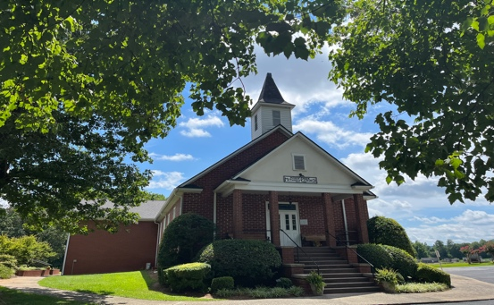
Mossy Creek United Methodist Church
March 30, 2023

Mossy Creek Messenger

Food for thought from J

And the crowds that went before him and that followed him were shouting, “Hosanna to the Son of David! Blessed is he who comes in the name of the Lord! Hosanna in the highest!
– Matthew 21:9

“Hosanna in the highest,” they shouted. How appropriate that Hosanna – derived from a Hebrew word meaning to rescue or to save – was used here, in this key moment from the life of Jesus, as a shout of praise for someone who was believed by many in the crowd to be the descendant of Israel’s greatest king, David. Surely this man would be the one to finally throw off the rule of the Roman empire, save God’s chosen people from oppression, and restore Israel to the position of greatness it had enjoyed under David and Solomon. And yet, somehow, the adoring crowds of that first “Palm Sunday” completely failed to consider what it might mean that the man they thought would be their king and deliverer came into their midst riding on a donkey. Somehow, they misunderstood his teaching that he came not to be served but to serve and to give his life as a ransom for many.

Unfortunately, even after 2000 years of research, study, and the development of orthodox theological creeds and doctrines around the life and teachings of Jesus, we can still fail to remember and consider these same aspects of the life of Jesus and what they mean for us who claim to seek to live by his example. But as Jesus taught his disciples in Matthew 20:26-27:

it shall not be so among you... whoever would be great among you must be your servant, and whoever would be first among you must be your slave.

This message to his disciples all those years ago remains as poignant as ever today as a defense in our own lives against forgoing our quest for the kingdom of God in favor of the pleasures and treasures of this fallen world. As we come to the final days of the Lenten season, may we remember and embrace the message of humility and self-sacrifice from the life of Jesus, even as we celebrate his miraculous resurrection, victory over sin and death, and ascension into Heaven to sit at the right hand of God the Father almighty as King of Kings and Lord of Lords.

WORSHIP NEWS

A Different Kind of King
In this week’s sermon we will consider the lessons to be learned from Matthew’s account of the final days of Jesus’s earthly life and what they can teach us about what it means to be his disciples. I hope you will join us as we enter Holy Week and the final days before Easter.

Never Miss a Sunday
If you can’t worship in person, you can watch our worship services on the Mossy Creek UMC Facebook page. Simply click on the link below to worship live or watch later at your convenience. Be sure to introduce your Facebook friends to our church and the gospel message by sharing our online worship with them.
https://www.facebook.com/mossycreekumc

Holy Week Schedule
Thursday, April 6 6:00 P.M. - Maundy Thursday dinner (Fellowship Hall)
Thursday, April 6 7:00 P.M. - Maundy Thursday Communion Service (Sanctuary)
Friday, April 7 6:00 P.M. - Good Friday Service (Sanctuary)
Sunday, April 9 7:00 A.M. - Easter Sunrise Service (Front Lawn)
Sunday, April 9 10:00 A.M. - Traditional Easter Service (Sanctuary)

DISCIPLESHIP/FELLLOWSHIP OPPORTUNITIES

Christian Education Opportunities
Sunday School – 9:00 AM every Sunday
We have classes for children of all ages that focus on providing age appropriate and foundational lessons about the Bible, its main characters, and the fundamental life lessons they hold for us today.
Our Choir Room class is currently reading C. S. Lewis’s Mere Christianity. We would love to have you join us Sunday mornings at 9:00 A.M in the choir room.
The Fellowship Hall class offers an opportunity for group prayer, fellowship, and spiritual devotion using such resources as the Upper Room. The class welcomes anyone wishing to engage in these important spiritual practices.
The Young at Heart class meets in the room adjacent to the church office and follows the traditional Cokesbury Sunday School curriculum.
Bible Studies and Small Groups
The Tuesday Bible study group is continuing an in-depth study of John’s gospel. We meet every Tuesday at noon in the Fellowship Hall. Next week we will be discussing chapter 20. It’s never too late to get involved in serious Bible study, and we hope you will consider joining us in studying God’s word from John’s gospel.
Our United Methodist Women are currently studying Shannon Bream’s book, The Mothers and Daughters of the Bible Speak. Their next meeting will be on Monday night, April 10th at 6:00 P.M. in the Fellowship Hall.
The United Methodist Men meet for breakfast on the second Sunday of each month to share food, fellowship, and a time of spiritual devotion.
Our Ladies Fellowship Group meets on the 3rd Wednesday of each month.

Children are our Future…
…but we need volunteers to work with our children on Sunday mornings and throughout the year, as we seek to grow disciples for the future of the church and God’s kingdom. If you have a gift for working with and teaching children, don’t wait to be asked to use your talent for God’s kingdom. Call the office or talk to J to volunteer.

Read the Bible in a Year
Week 35
Day 1 - Isaiah 23-25, 1 Corinthians 3
Day 2 - Isaiah 26-29, Psalm 65, 1 Corinthians 4
Day 3 - Isaiah 30-32, 1 Corinthians 5
Day 4 - Isaiah 33-35, 1 Corinthians 6
Day 5 - 2 Chronicles 28, 2 Kings 17, Psalm 66, 1 Corinthians 7

Gifts
Supporting the church with our tithes and offerings is necessary for the life of the church and as an important spiritual practice for growing as a disciple and exercising our faith in God’s providence. Fortunately, there are several ways for you to give at Mossy Creek. In addition to weekly offering during worship, contributions can be placed in the box outside the office marked “Sally,” they can be mailed to the church at PO Box 557, Cleveland, GA 30528, and they may be made electronically by clicking the “donate here” button of the church web site. Thank you for your continuing financial support of our church.

Our Easter Egg and Cookout…
…was a wonderful success. We had over 25 children participate in the egg hunt, and our new building was filled with church family enjoying a great time of food and fellowship. Of course, none of this would have been possible without the hard work of a dedicated group of volunteers. Thanks so much to those who gave their time and talents to make this event possible.

wOf course

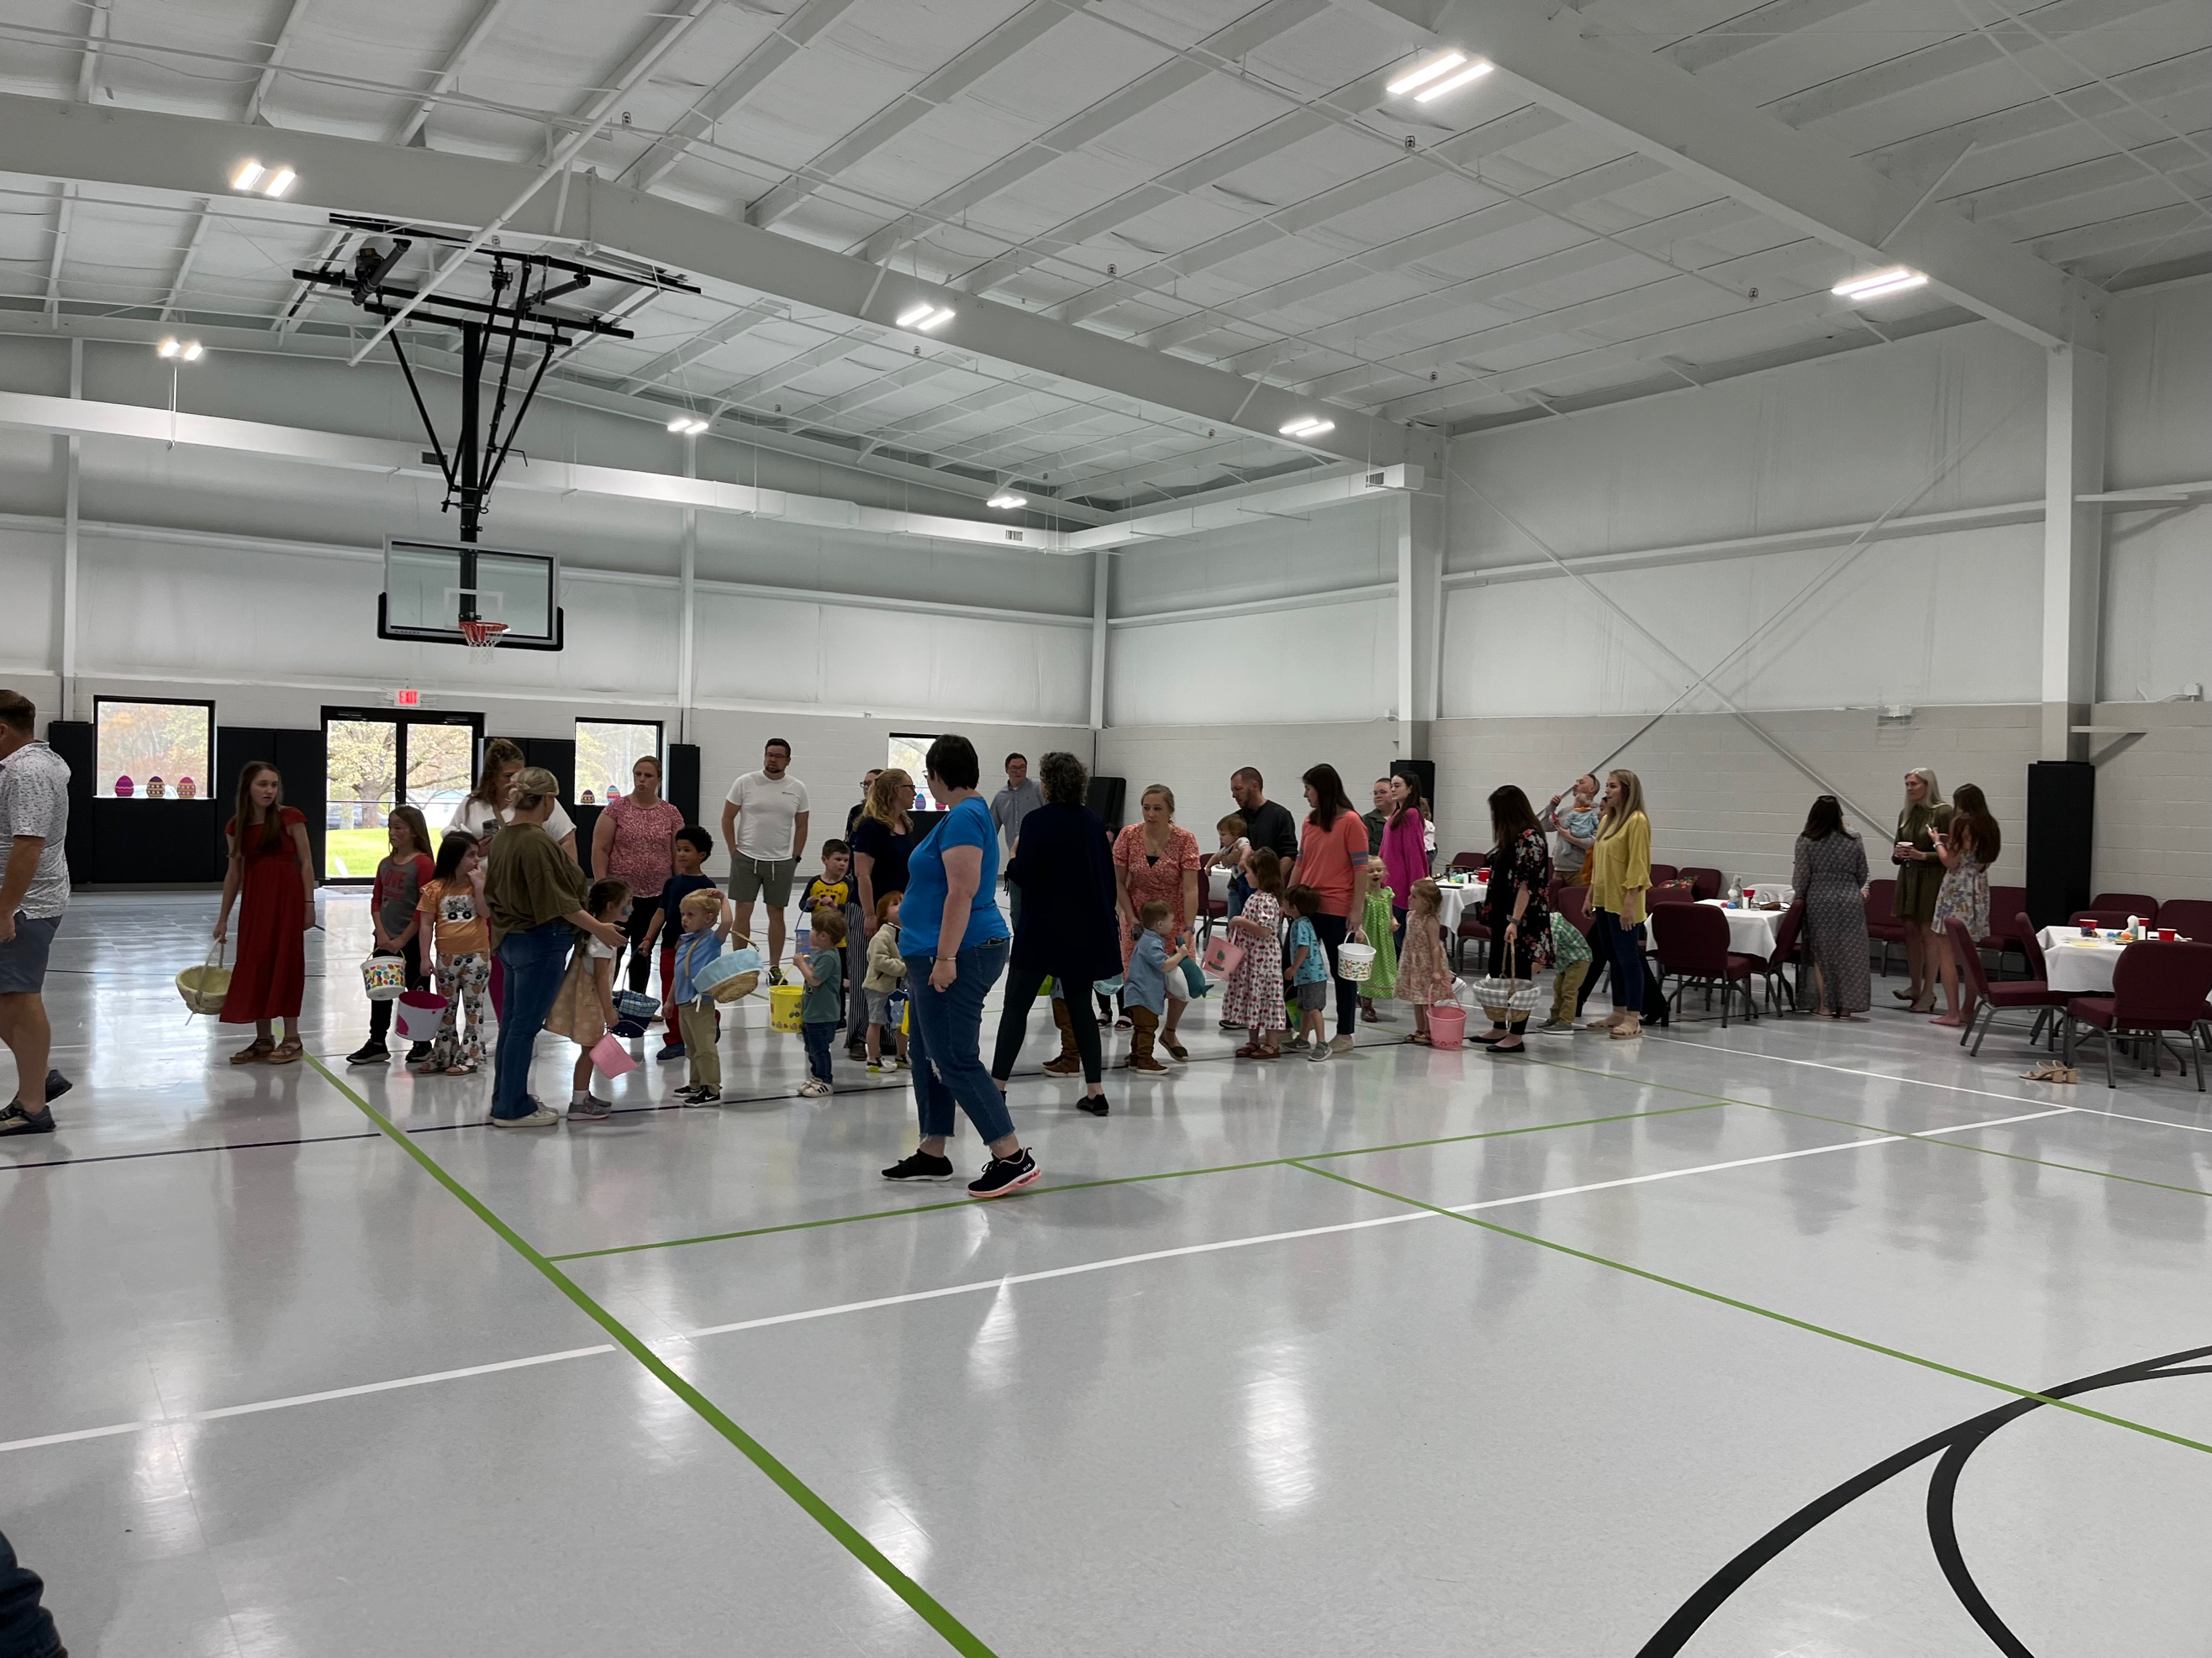
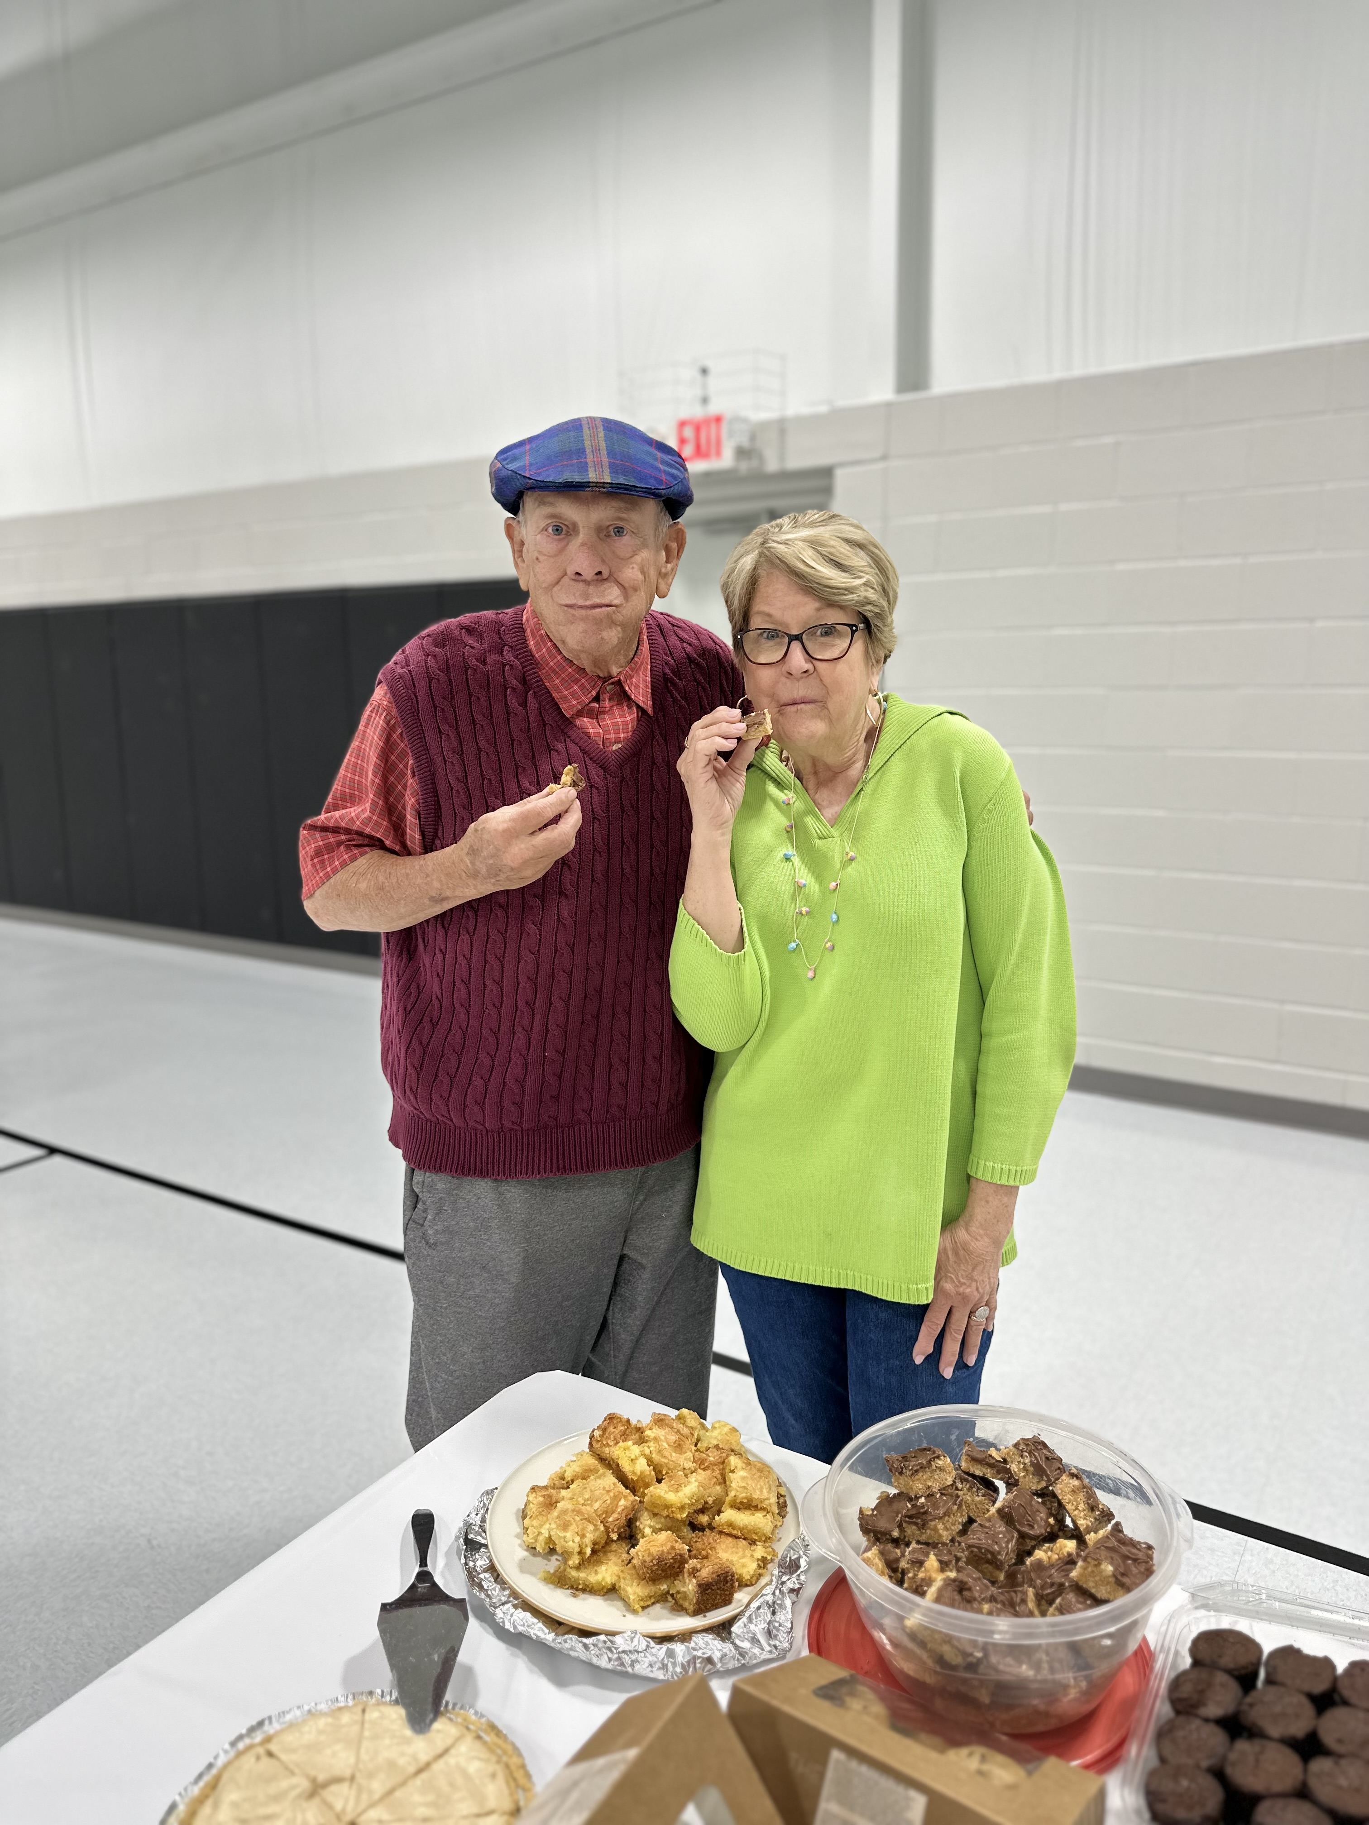

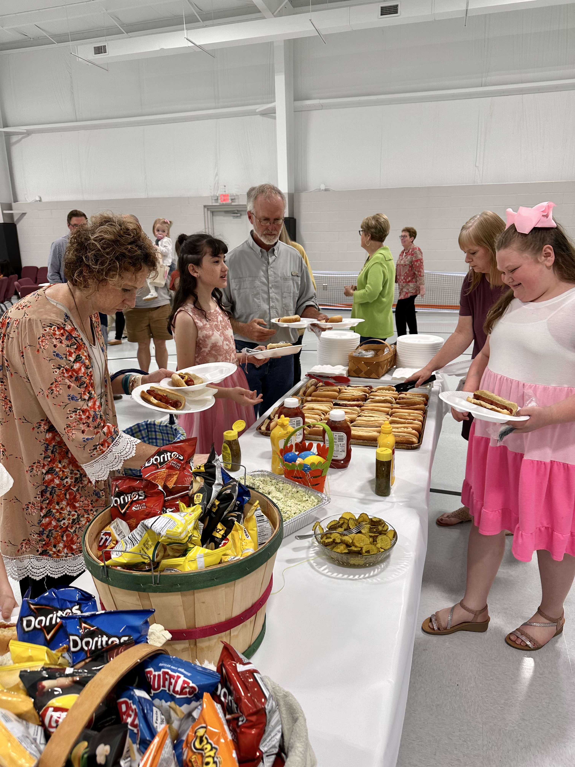
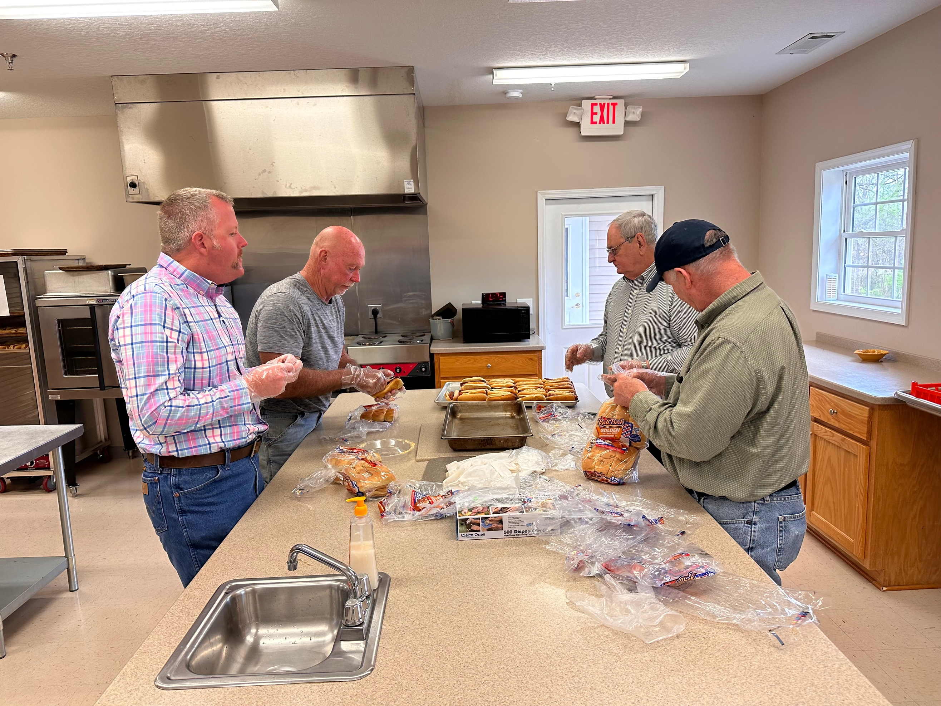
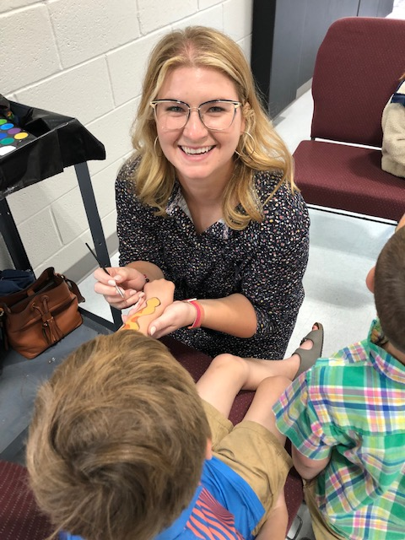

FACTS AND FIGURES
Recent Attendance
In-person Facebook views
Mar. 26, 2023 110 70
Mar. 19, 2023 89 44
Mar. 12, 2023 74 130
Mar. 5, 2023 92 46

Financial Report
General Fund – Through February 2023
- 2023 YTD Receipts $39,631.00
- 2023 YTD Expenses $39,919.00
- Net income/(loss) ($ 288.00)
Building Fund – Through February 2023
- 2023 YTD Receipts $ 27,339.00
- YTD Balance $ 46,118.00

March Birthdays
3/2 – Sally Crowe
3/3 – Doug Head
3/6 – Mike Rogers
3/7 – Lora Everette
3/8 – Randall Campbell
3/9 – Lily Kostulakos
3/10 – Ella Blair
3/11 - Jon Kostulakos
3/13 - Laurene Sosebee
3/14 - Hazel Fain
3/15 - Connie Campbell
3/20 - Mike Dorsey, David Hollingsworth
3/21 - Grant Keene
3/29 - Allen Head

March Anniversaries
3/27 - Brad and Vicky Hunt

NEW PRAYER NEEDS AND CONCERNS

- Harry Barton
- Seth McAvoy
- Susie Caudell
- Charlie Brown
- Amanda Hansen
- Family of Donald Hunt
- Family of Phillip Nix
- Family of Joan Chastain Cole

BUILDING UPDATE
New Building Available for Limited Use
While we await the last steps in completing our new building and receiving our final Certificate of Occupancy, the building is now available for limited use by our members. If you would like to reserve the building for an event or activity, please contact the church office to inquire about availability.

